**Control Systems Portfolio Assignment**

**RA2011004010051**

**Kunal Keshan ECE A**

Q. Design a system Transfer function G(S) = Using MATLAB. Observe its response for step input and control the response using Integral Controller.

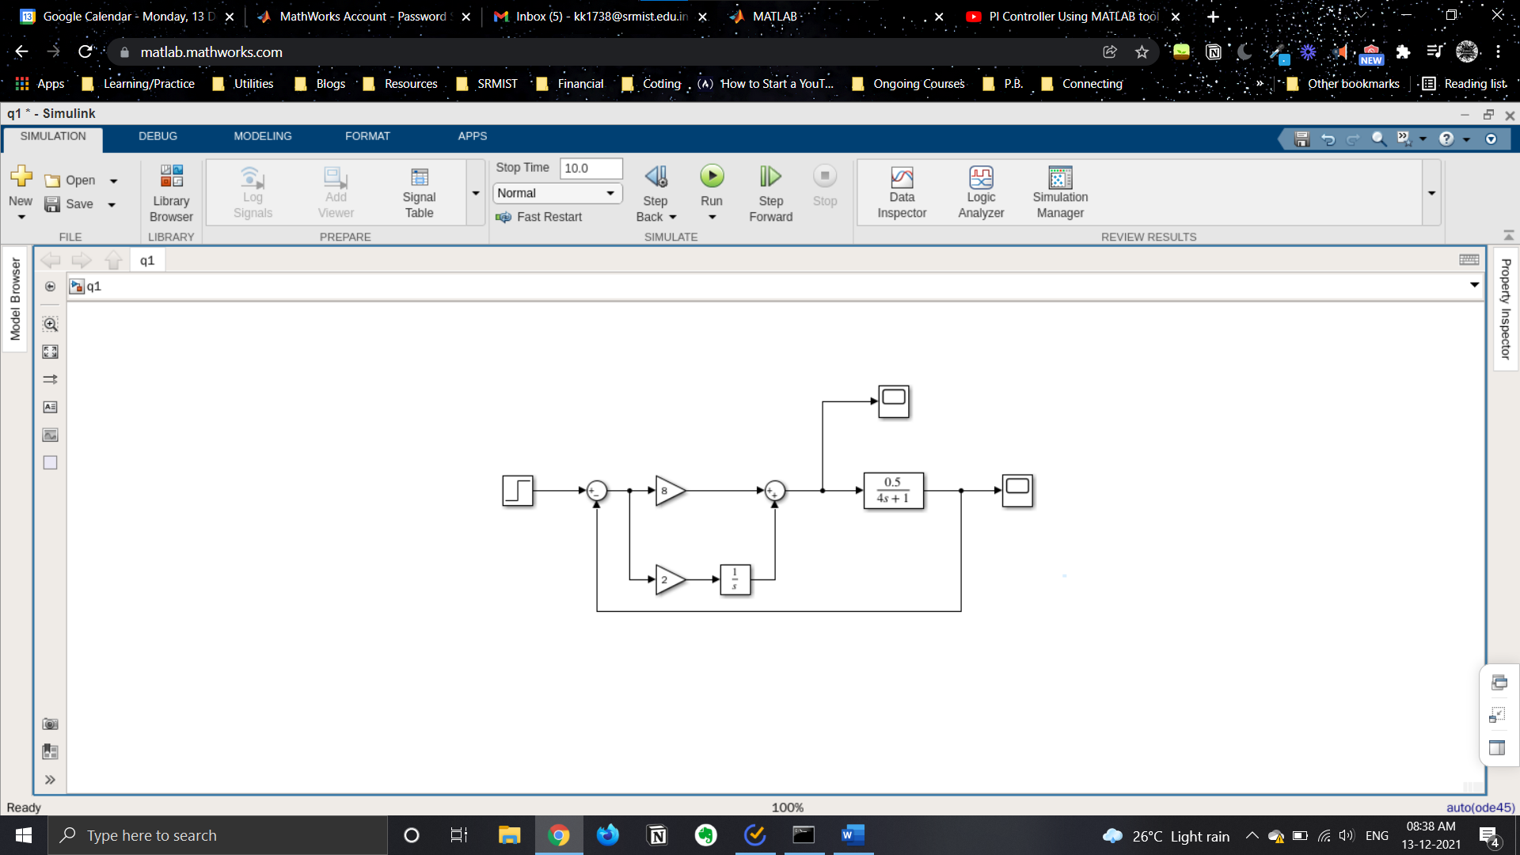

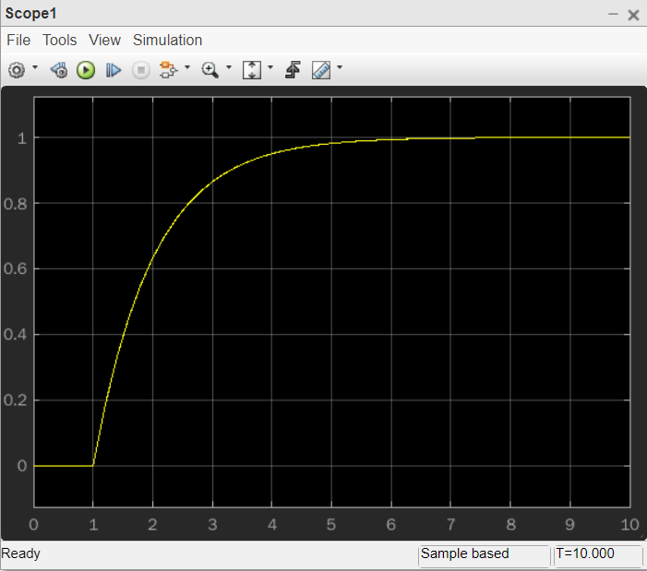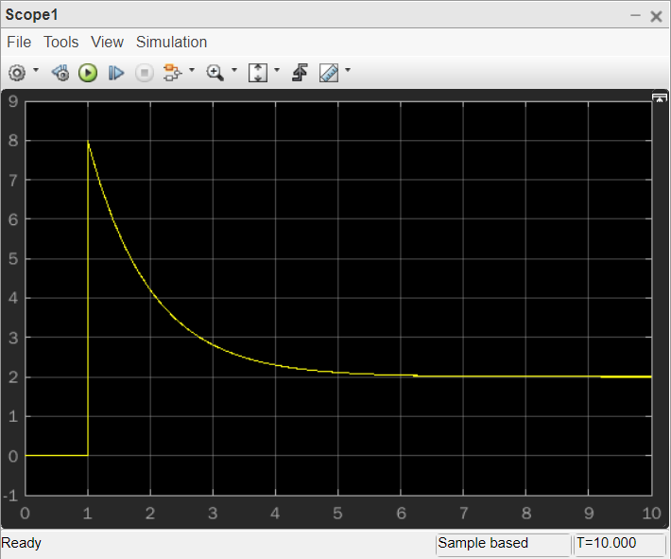

Q. Reduce the block diagram using MATLAB functions.

